Title of the Paper 22 font size,and Times New Roman
Author¹(12font Size,Bold,Italic)
Designation, Department, College, City, Country ¹

Abstract:Abstarct contains 10 font size,bold and Italic,Times new roman. This document gives formatting instructions for authors preparing papers for publication in the Proceedings of an International Journal. The authors must follow the instructions given in the document for the papers to be published. You can use this document as both an instruction set and as a template into which you can type your own text.
Keywords: Include at least 4 keywords or phrases.

I.Introduction
(All content font size is 11,Times new romans,Line and para graph space is Single) Multicast IP is a bandwidth conserving technology that reduces traffic in the network. Protocol Independent Multicast (PIM)is a family of routing protocols that form multicast trees to forward traffic from multicast sources to subnets.PIM relies on the unicast routing tables created by any of several unicast routing protocols to identify the path back to a multicast source (reverse path forwarding, or RPF)[2]. With this information, PIM sets up the distribution tree for the multicast traffic. The PIM-SM protocols on the switch enable and control multicast traffic routing. PIM-SM is used to reduce the effect of multicast traffic flows in network areas because,it does not automatically flood traffic, it is a logical choice in lower bandwidth situations.
II.PROPOSED WORK
An easy way to comply with the conference paper formatting requirements is to use this document as a template and simply type your text into it.
III.Results
All paragraphs must be indented. All paragraphs must be justified, i.e. both left-justified and right-justified.
- Text Font of Entire Document
The entire document should be in Times New Roman or Times font. Type 3 fonts must not be used. Other font types may be used if needed for special purposes.
Recommended font sizes are shown in Table 1.
TABLE I
Font Sizes for Papers
Font Size | Appearance (in Time New Roman or Times)
Font Size | Regular | Bold | Italic
8 | table caption (in Small Caps),  figure caption,  reference item |  | reference item (partial)

All title and author details must be in single-column format and must be centered.
- Section Headings
No more than 3 levels of headings should be used. All headings must be in 10pt font. Every word in a heading must be capitalized except for short minor words as listed in Section III- Figures and Tables
Figures and tables must be centered in the column. Large figures and tables may span across both columns. Any table or figure that takes up more than 1 column width must be positioned either at the top or at the bottom of the page. Graphics must not use stipple fill patterns because they may not be reproduced properly. Please use only SOLID FILL colors which contrast well both on screen and on a black-and-white hardcopy, as shown in Fig. 1.

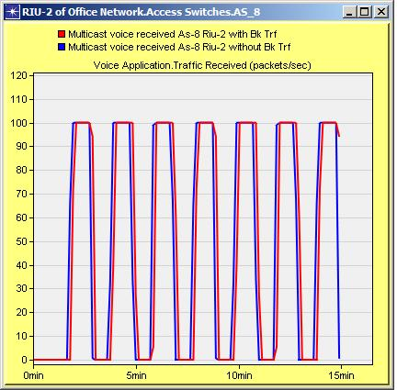
Fig. 1 A sample line graph using colors which contrast well both on screen and on a black-and-white hardcopy
Fig. 2 shows an example of a low-resolution image which would not be acceptable, whereas Fig. 3 shows an example of an image with adequate resolution. Check that the resolution is adequate to reveal the important detail in the figure. Please check all figures in your paper both on screen and on a black-and-white hardcopy. When you check your paper on a black-and-white hardcopy, please ensure that:
- the colors used in each figure contrast well,
- the image used in each figure is clear,
- all text labels in each figure are legible.

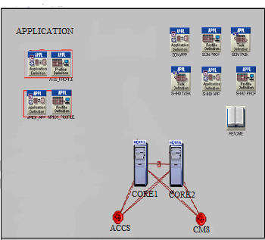

Fig. 2. Example of an unacceptable low-resolution image

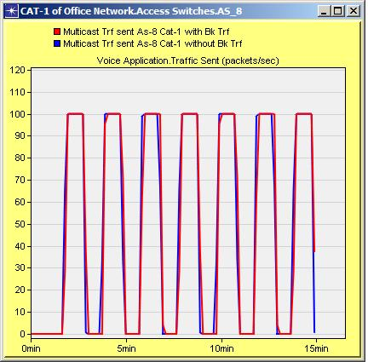
Fig. 3. Example of an image with acceptable resolution

- Table Captions
Tables must be numbered using uppercase Roman numerals. Table captions must be centred and in 8 pt Regular font with Small Caps. Captions with table numbers must be placed before their associated tables, as shown in Table 1.
- Page Numbers, Headers and Footers
Page numbers, headers and footers must not be used.
- Links and Bookmarks
All hypertext links and section bookmarks will be removed from papers during the processing of papers for publication. If you need to refer to an Internet email address or URL your paper, you must type out the address or URL fully in Regular font.
- References
The heading of the References section must not be numbered. All reference items must be in 8 pt font. Please use Regular and Italic styles to distinguish different fields as shown in the References section. Number the reference items consecutively in square brackets (e.g. [1]). When referring to a reference item, please simply use the reference number, as in [2].

Examples of reference items of different categories shown in the References section include:

IV. Conclusion
The version of this template is V2. Most of the formatting instructions in this document have been compiled by Causal Productions from the IEEE LaTeX style files.
ACKNOWLEDGMENT
The heading of the Acknowledgment section and the References section must not be numbered.Causal Productions wishes to acknowledge Michael Shell and other contributors .
References
(References font size 9,Times New Roman)
- S. M. Metev and V. P. Veiko, Laser Assisted Microtechnology, 2nd ed., R. M. Osgood, Jr., Ed. Berlin, Germany: Springer-Verlag, 1998.
[2] J. Breckling, Ed., The Analysis of Directional Time Series: Applications to Wind Speed and Direction, ser. Lecture Notes in Statistics. Berlin, Germany: Springer, 1989, vol. 61.
- S. Zhang, C. Zhu, J. K. O. Sin, and P. K. T. Mok, “A novel ultrathin elevated channel low-temperature poly-Si TFT,” IEEE Electron Device Lett., vol. 20, pp. 569–571, Nov. 1999.
- M. Wegmuller, J. P. von der Weid, P. Oberson, and N. Gisin, “High resolution fiber distributed measurements with coherent OFDR,” in Proc. ECOC’00, 2000, paper 11.3.4, p. 109.
- R. E. Sorace, V. S. Reinhardt, and S. A. Vaughn, “High-speed digital-to-RF converter,” U.S. Patent 5 668 842, Sept. 16, 1997.
- (2002) The IEEE website. [Online]. Available: http://www.ieee.org/
- M. Shell. (2002) IEEEtran homepage on CTAN. [Online]. Available: http://www.ctan.org/tex-archive/macros/latex/contrib/supported/IEEEtran/
- FLEXChip Signal Processor (MC68175/D), Motorola, 1996.
- “PDCA12-70 data sheet,” Opto Speed SA, Mezzovico, Switzerland.
- A. Karnik, “Performance of TCP congestion control with rate feedback: TCP/ABR and rate adaptive TCP/IP,” M. Eng. thesis, Indian Institute of Science, Bangalore, India, Jan. 1999.
- J. Padhye, V. Firoiu, and D. Towsley, “A stochastic model of TCP Reno congestion avoidance and control,” Univ. of Massachusetts, Amherst, MA, CMPSCI Tech. Rep. 99-02, 1999.
- D Kosiur, “IP Multicasting:The complete giuide Interactive corporate Networks”Willey Computer Publishers 2002.
- N.Bhaskar, A Gal,J Lingard, S Venaas, “ BootStrapRouter Mechanism for PIM ” ,IETF RFC 5059,Jan 2008
- Todor Blaga, Virgil Dobrota, Daniel Zinca, Gabriel Lazar,”Multicast Routing in IPV4/IPV6 using Linux and Free BSD”, 2004
- Mil3 Inc., “OPNET Reference Materials”, http://www.mil3.com
- Xin wang,Paul Strik “IP Multicast Fault Recovery in PIM over OSPF”,Dept of CS Columbia University”

BIOGRAPHY

First Author personal profile which contains their education details, their publications, research work, membership, achievements, with photo that will be maximum 200-400 words.
Second Author personal profile which contains their education details, their publications, research work, membership, achievements, with photo that will be maximum 200-400 words.

